***Objective* -:** (i) Predict the direction of the magnetic field for different locations around a bar magnet and an electromagnet.

(ii) Compare and contrast bar magnets and electromagnets.

(iii) Identify the characteristics of electromagnets that are variable and what effect each variable has on the magnetic field strength and direction.

(iv) Relate magnetic field strength to distance quantitatively and qualitatively.

(v) Identify equipment and conditions that produce induction.

(vi) Compare and contrast how both a light bulb and voltmeter can be used to show characteristics of the induced current.

(vii) Predict how the current will change when the conditions are varied.

***Theory*** **-:**

A bar magnet is a rectangular piece of an object, made up of iron, steel or any other ferromagnetic substance or ferromagnetic composite, that shows permanent magnetic properties. It has two poles, a north and a south pole such that when suspended freely, the magnet aligns itself so that the northern pole points towards the magnetic north pole of the earth.

***Properties of Bar Magnet***

A bar magnet has properties similar to any permanent magnet.

* It has a north pole and a south pole at two ends. Even if you break a bar magnet from the middle, both the pieces will still have a north pole and a south pole, no matter how many pieces you break it in.
* The magnetic force of it is the strongest at the pole.
* If this magnet is suspended freely in the air with a thread, it will not come to rest until the poles are aligned in a north-south position. A Mariner’s Compass uses this property to determine direction.
* If two bar magnets are placed close to each other, their unlike poles will attract and like poles will repel each other.
* A bar magnet will attract all ferromagnetic materials such as iron, nickel and cobalt.

***Magnetic Field Lines Around a Bar Magnet***

The magnetic field lines can be defined as imaginary lines that can be drawn along the magnetic field that is acting around any magnetic substance. The magnetic field lines possess certain properties,

* The magnetic field lines of a magnet form continuous closed loops.
* The tangent to the field line at any point represents the direction of the net magnetic field B at that point.
* The larger the number of field lines crossing per unit area, the stronger is the magnitude of the magnetic field B.
* The magnetic field lines do not intersect.

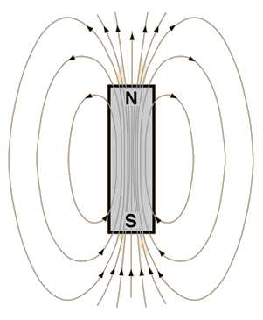

The figure shows the magnetic field lines around a bar magnet.

***Faraday’s Law of Electromagnetic Induction***

***1st Law –:*** Whenever a conductor is placed in a varying magnetic field, an electromotive force is induced. If the conductor circuit is closed, a current is induced, which is called induced current.

***2nd Law –:*** The induced emf in a coil is equal to the rate of change of flux linkage.

$$Ɛ= -N\frac{∆φ}{∆t}$$

***Lenz’s Law***

The polarity of induced emf is such that it tends to produce a current which opposes the change in magnetic flux that produced it.

***Electromagnet***

An electromagnet is a type of magnet in which the magnetic field is produced by an electric current. Electromagnets usually consist of wire wound into a coil. A current through the wire creates a magnetic field which is concentrated in the hole, denoting the centre of the coil. The magnetic field disappears when the current is turned off. The wire turns are often wound around a magnetic core made from a ferromagnetic or ferrimagnetic material such as iron; the magnetic core concentrates the magnetic flux and makes a more powerful magnet.

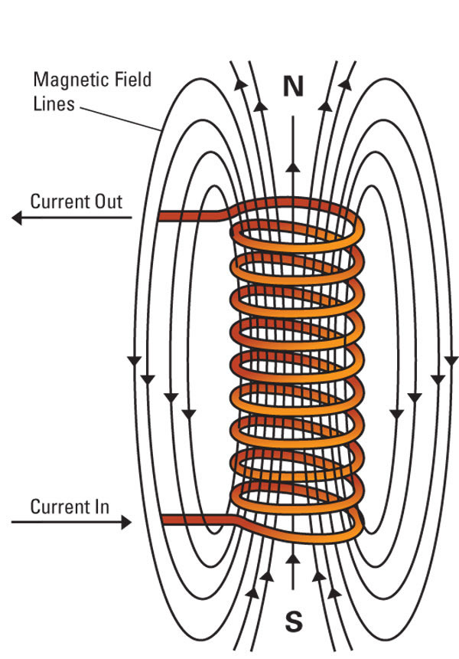***Magnetic Field Lines Around an Electromagnet***

The magnetic field lines around an electromagnet are shown in the figure above. Notice, the magnetic field lines are similar to that around a bar magnet.

***Note*** -: The north pole of the electromagnet is determined by using your right hand. Wrap your fingers around the coil in the same direction as the current is flowing (conventional current flows from + to -). The direction your thumb is pointing is the direction of the magnetic field, so north would come out of the electromagnet in the direction of your thumb.

***Observations And Conclusions* -:**

***Objective(i)***

The direction of magnetic field can be predicted from the magnetic field lines around a bar magnet/electromagnet.

* Magnetic field around a bar magnet

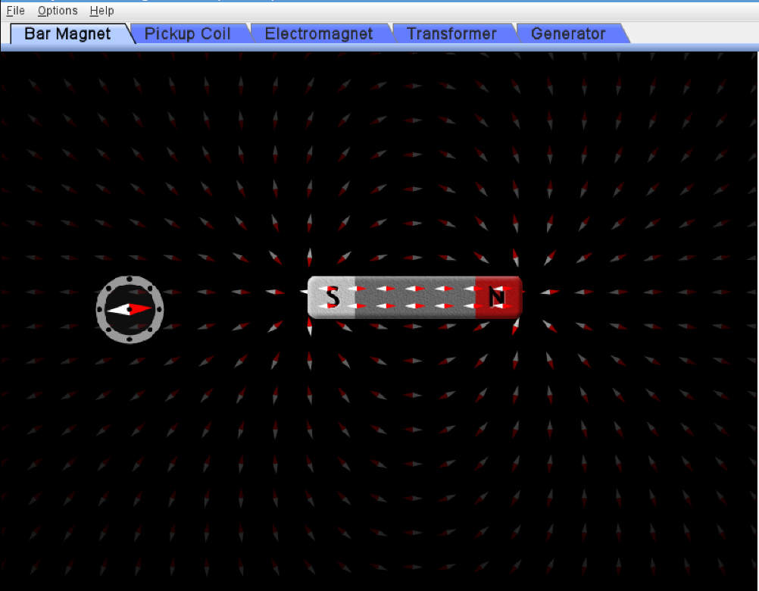

* Magnetic Field around an electromagnet

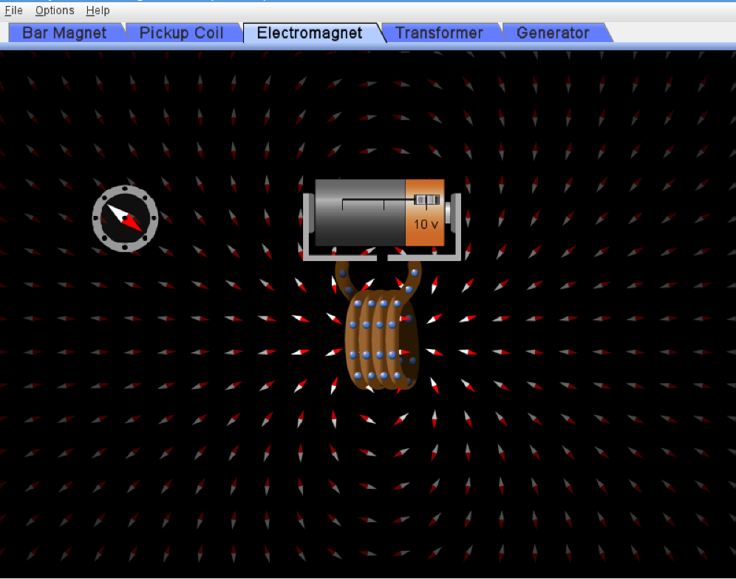

***Conclusion -:*** The direction of the magnetic field can be predicted using the following points –

* The direction of magnetic field is from north pole to south pole outside a bar magnet/electromagnet.
* The direction of magnetic field is from south pole to north pole inside a bar magnet/electromagnet.

***Objective(ii)***

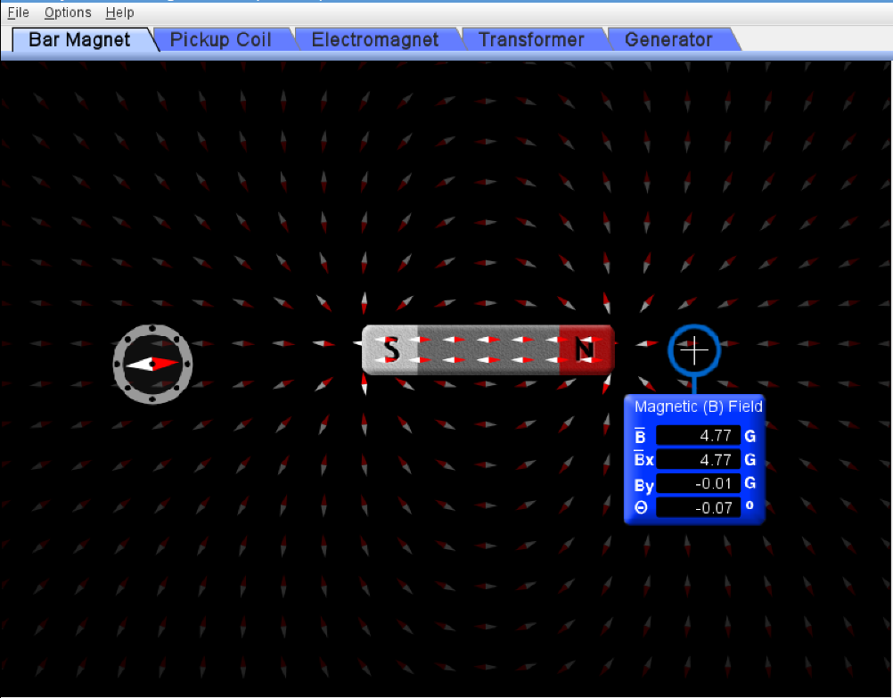

ss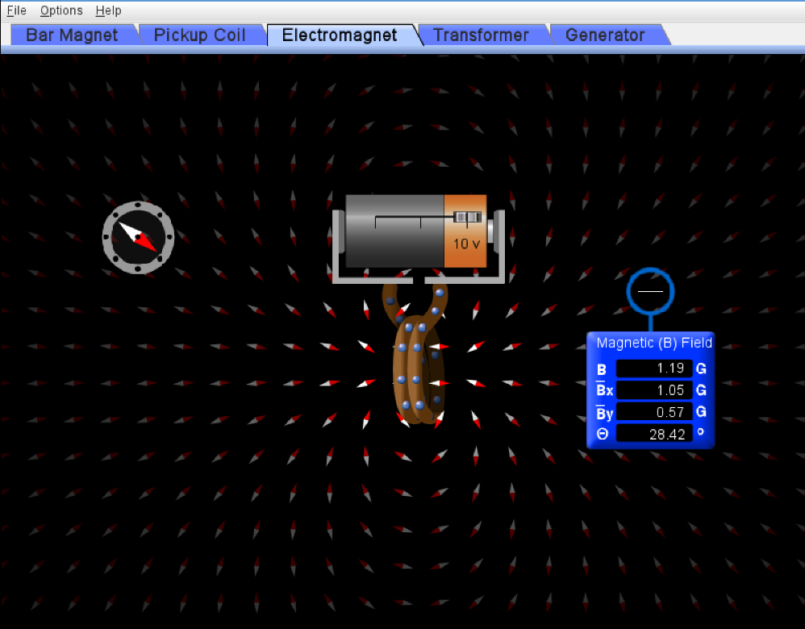

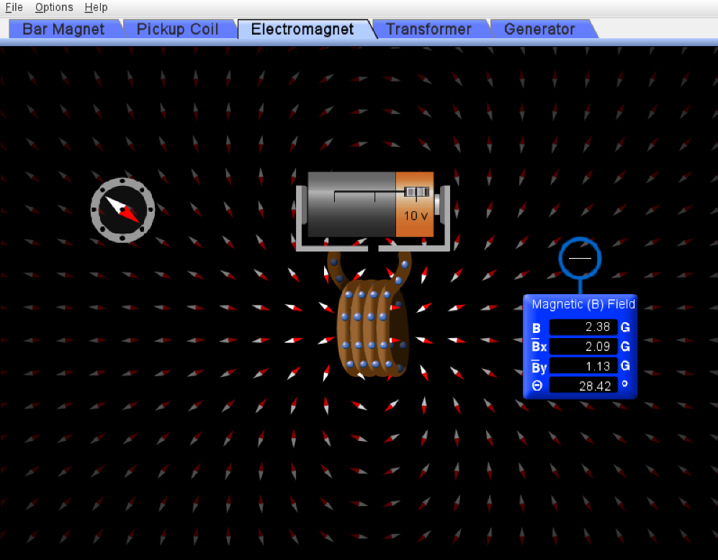

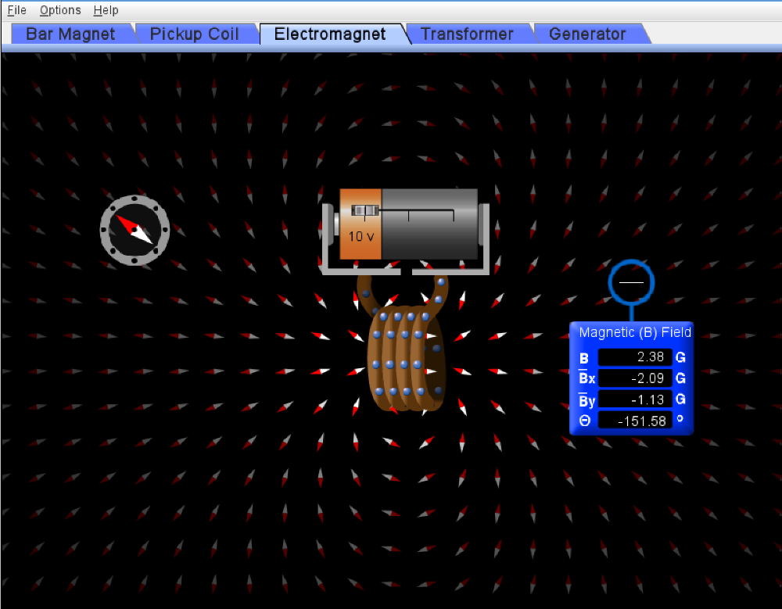

***Conclusion -:*** Though electromagnets and bar magnets show similar magnetic fields but the following are the differences between them:

* Bar magnets generate their own magnetic field while electromagnets depend on the external sources of electric current for the generation of magnetic field.
* Bar magnets have a constant magnetic pull as they are permanent magnets while electromagnets do not have a constant magnetic pull as they are controlled by external source of electric current.
* The magnetic force of the bar magnet is constant and is dependent on the material it is made from while the magnetic force of an electromagnet can be varied by varying the amount of electricity flowing through the coil and varying the number of turns in its coil. (as can be observed in the observation snap 2 – 4 in Objective (ii).

***Objective(iii)***

Keeping the meter at a fixed position and varying the current in the coil by varying the potential of the battery and also varying the number of turns in the coil.

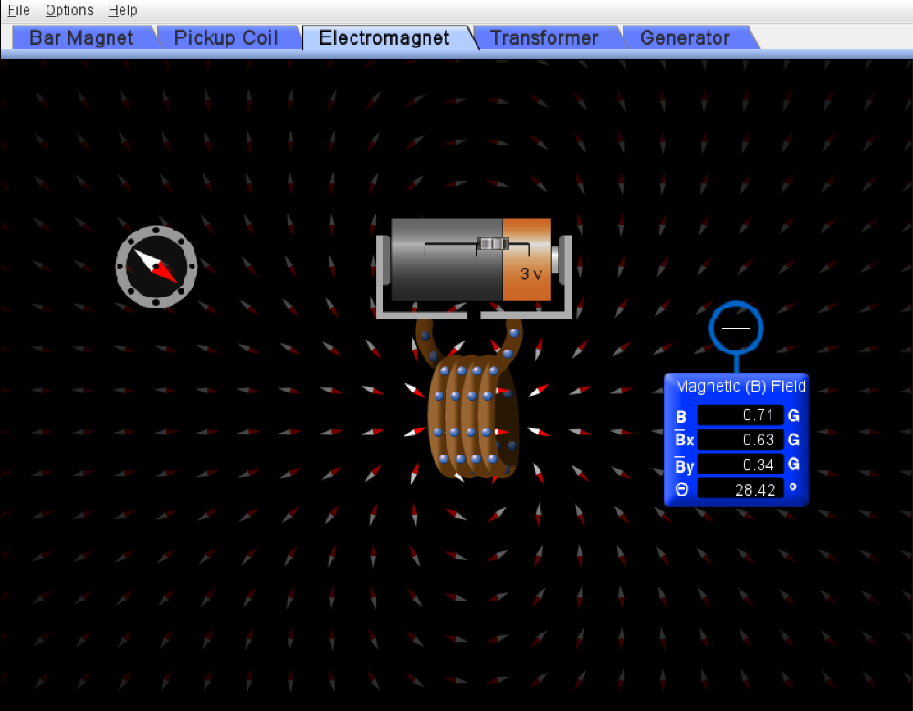

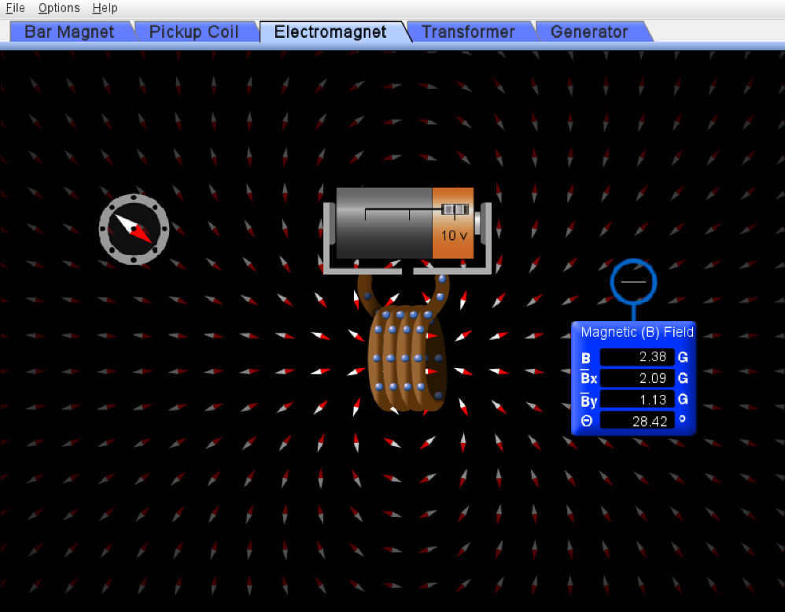

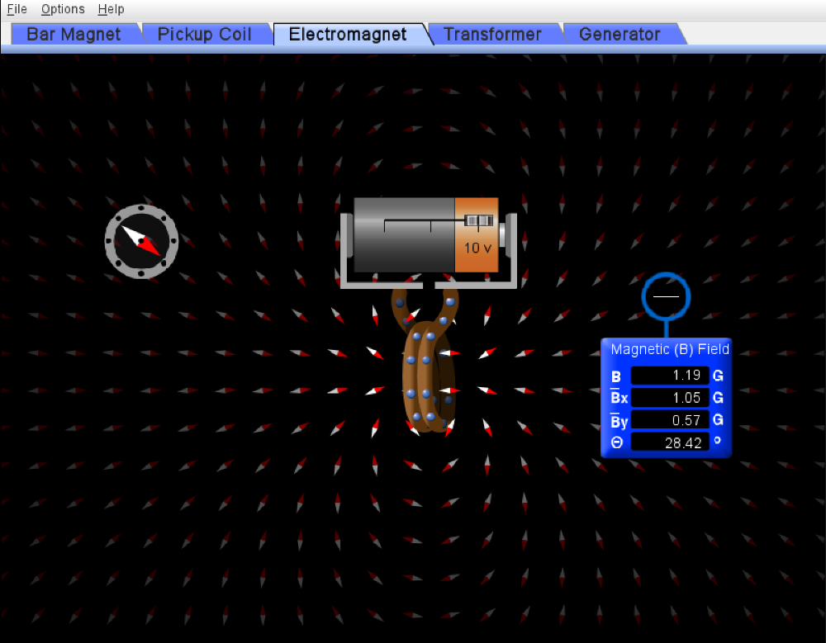

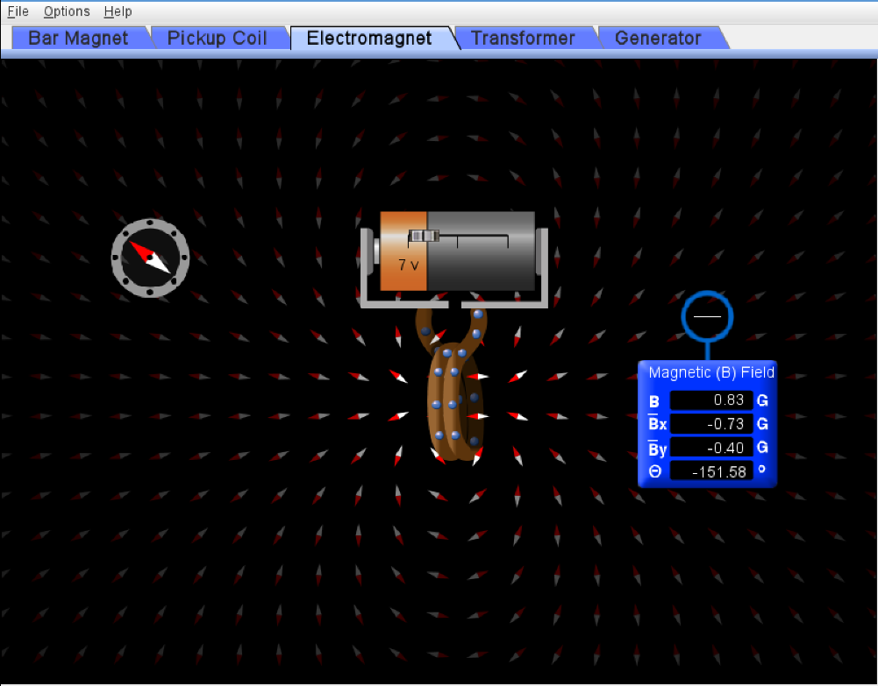

***Conclusion -:*** From the experiment it can be concluded that the variable parameters in an electromagnet are the current and the number of turns in its coil.

These variables have the following effect on the magnetic field strength of the electromagnet -:

* On increasing the current in the coil, the magnetic field strength also increases. It can be observed in Snap 1 and 2. On increasing the voltage from 3 V to 10 V (thereby the current) the magnetic field strength is increased from 0.71 T to 2.38 T.
* On increasing the number of turns in the coil, the magnetic field strength increases (directly proportional). It can be observed in Snap 2 and Snap 3. On reducing the turns in the coil from 4 to 2, the magnetic field strength reduces from 2.38 T to 1.19 T.
* On reversing the polarity of the voltage source, the polarity of the electromagnet also reverses. This can be observed in the Snap 3 and 4.

***Objective(iv)***

* ***Variation of magnetic field strength around bar magnet with distance***

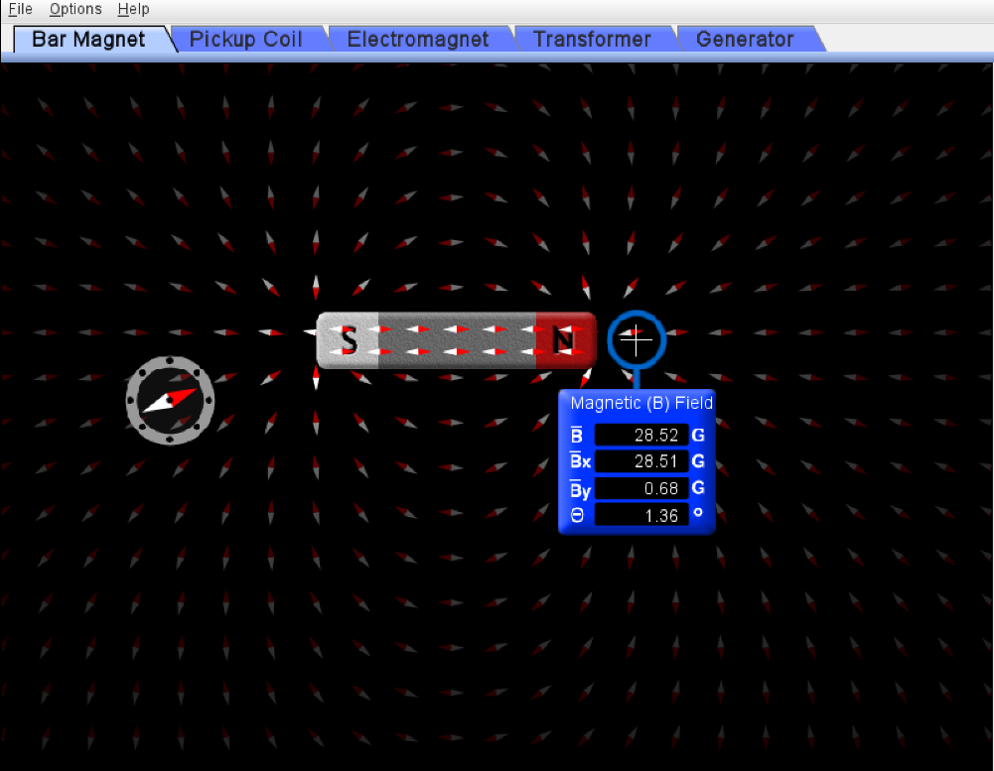 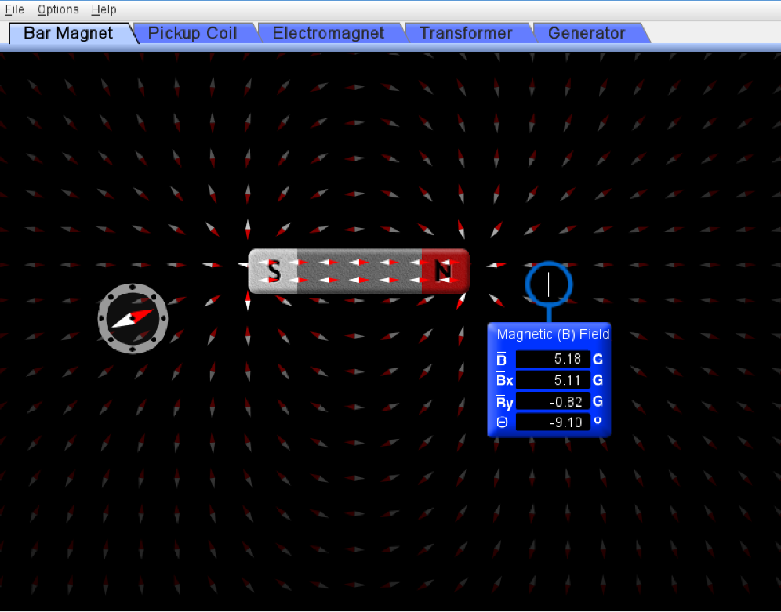

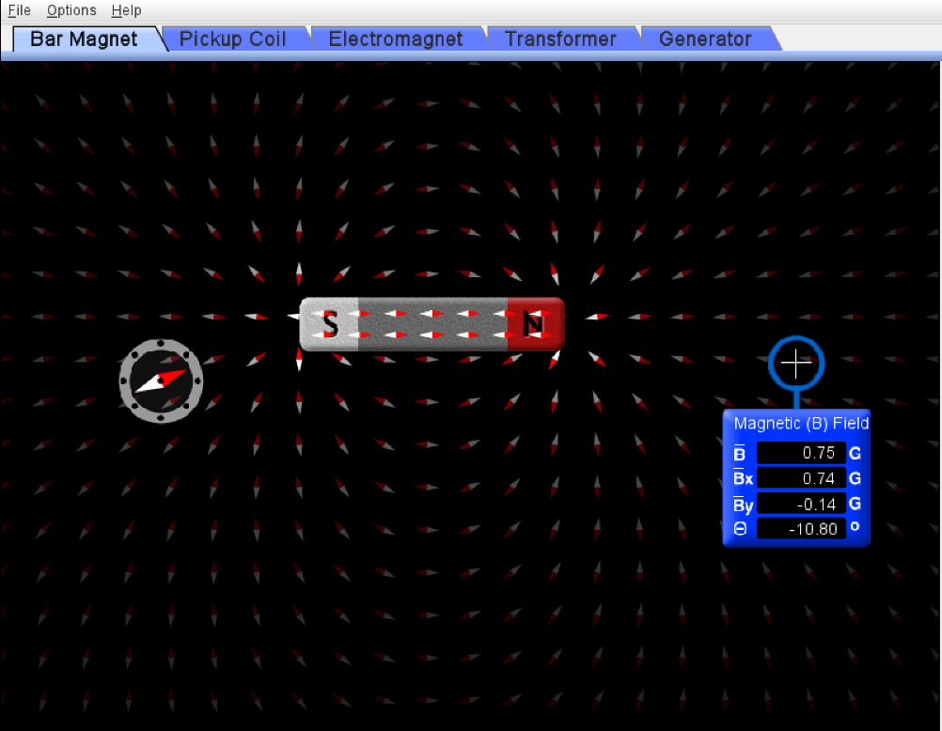

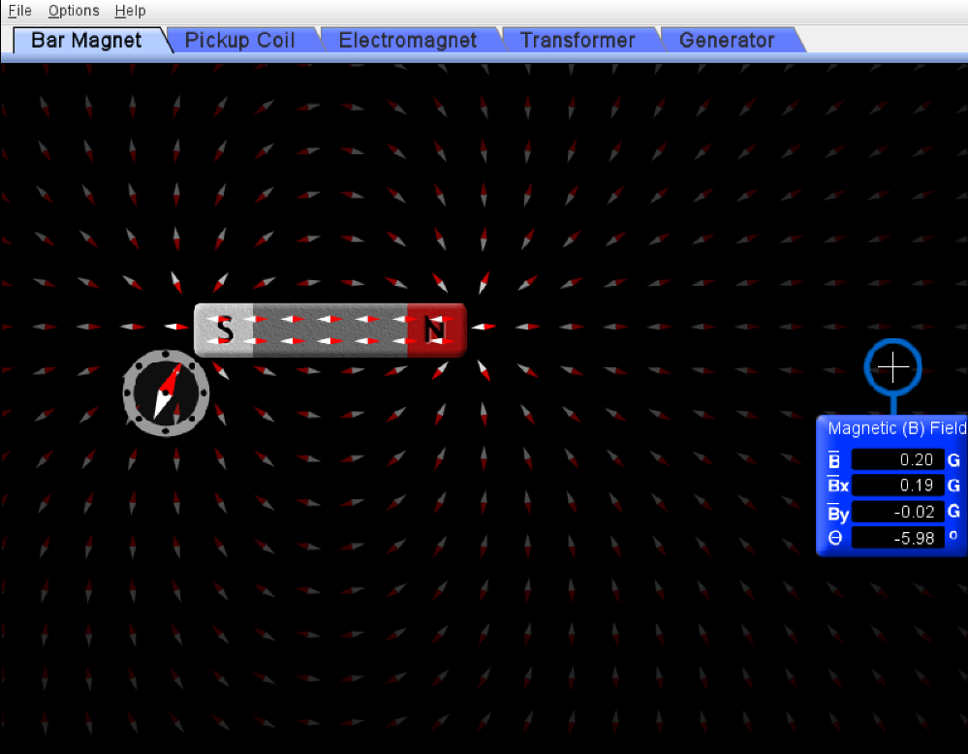

* ***Variation of magnetic field strength around electromagnet with distance***

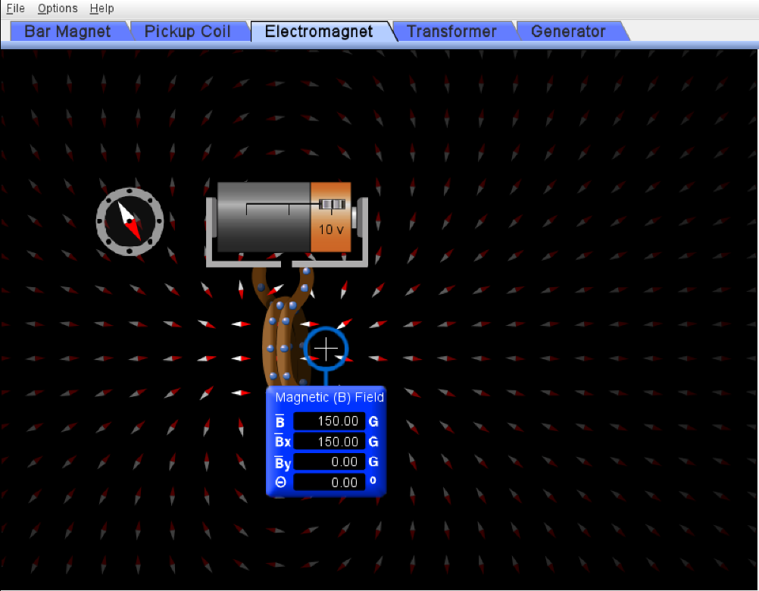

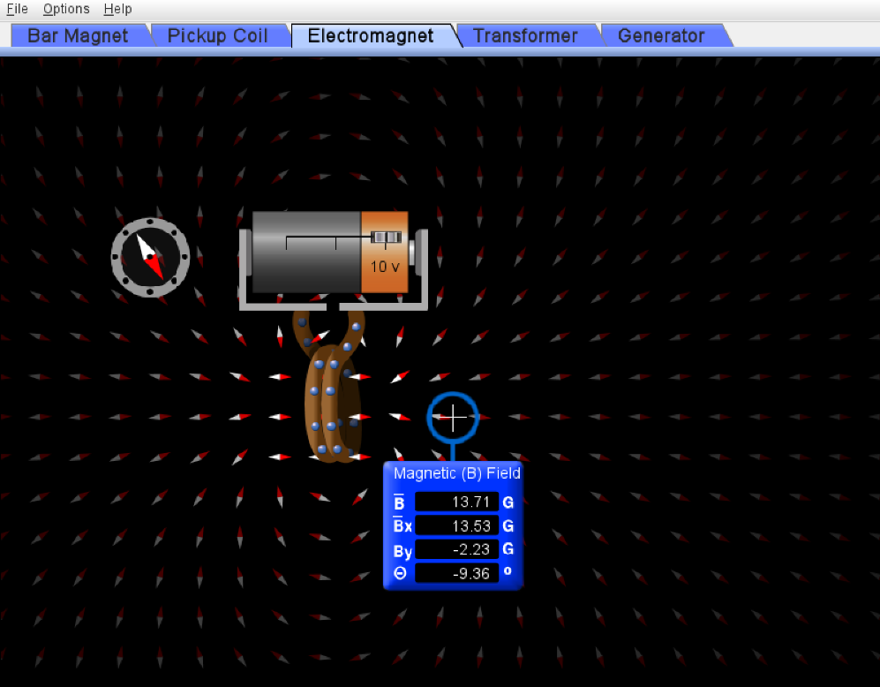

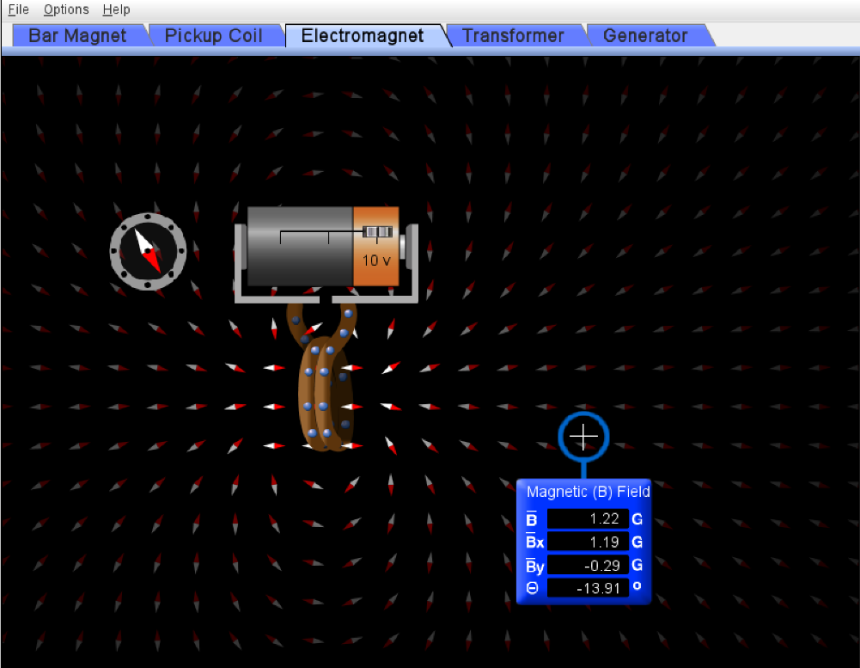

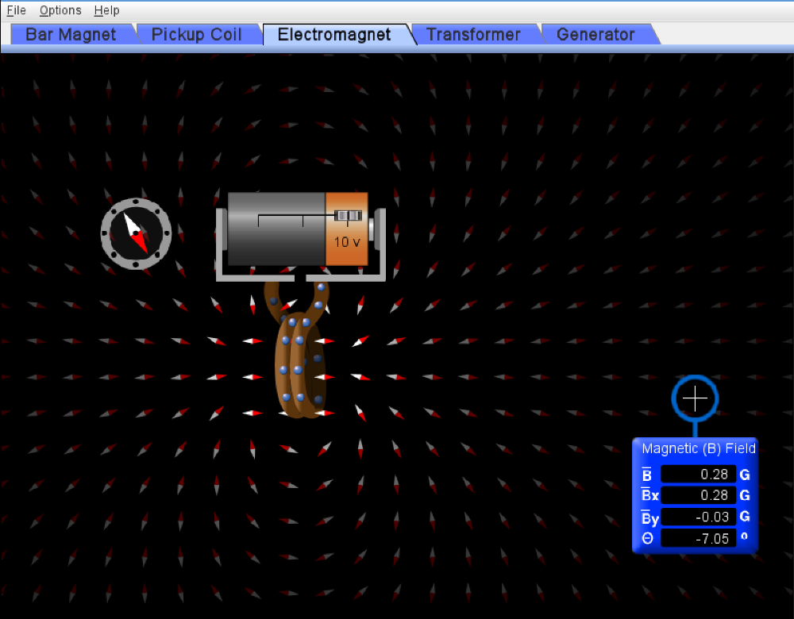

***Conclusion -:*** Observing the variation of magnetic field strength of a bar magnet/electromagnet with distance, following conclusions were drawn -:

* Qualitatively, the magnetic field strength of a bar magnet/electromagnet decreases with increase in distance.
* Quantitatively, the magnetic field strength of a bar magnet/electromagnet is inversely proportional to the square of distance from it.

$$B α \frac{1}{r^{2}}$$

***Objective(v)***

The equipments required for induction are -:

* External magnetic field -: This can be generated using a bar magnet/electromagnet or any other source.
* A closed electric circuit -: for instance, a circuit with a bulb or it can be just a loop of wire.

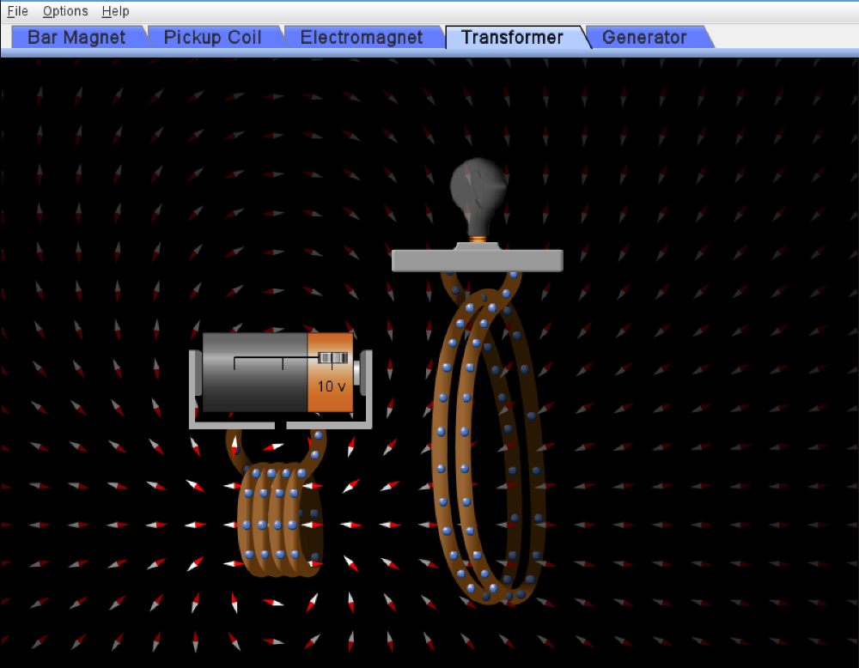

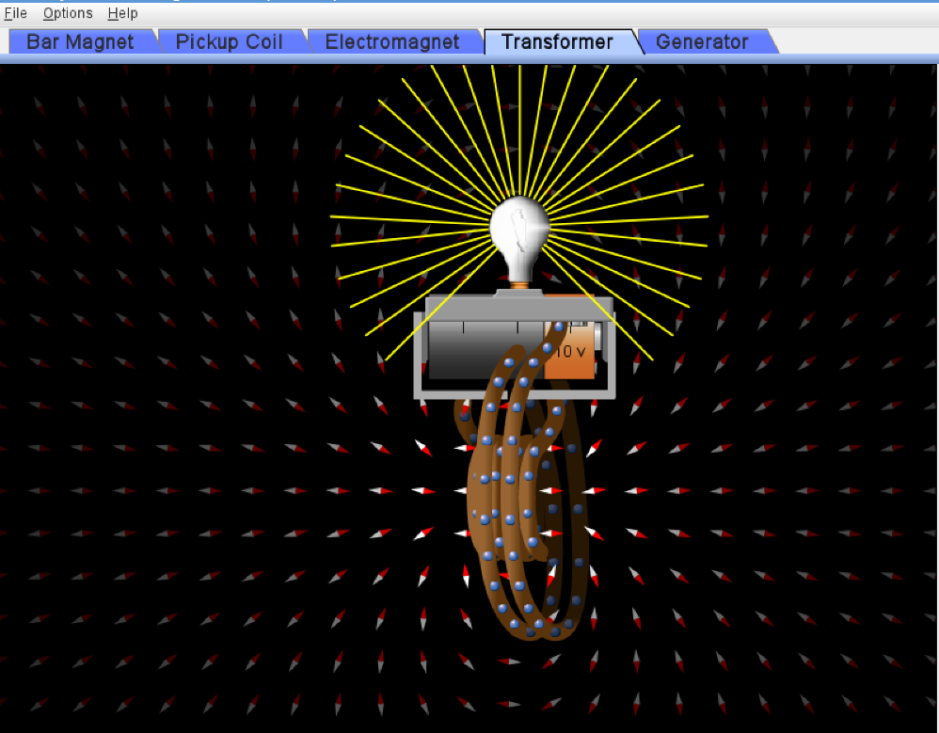

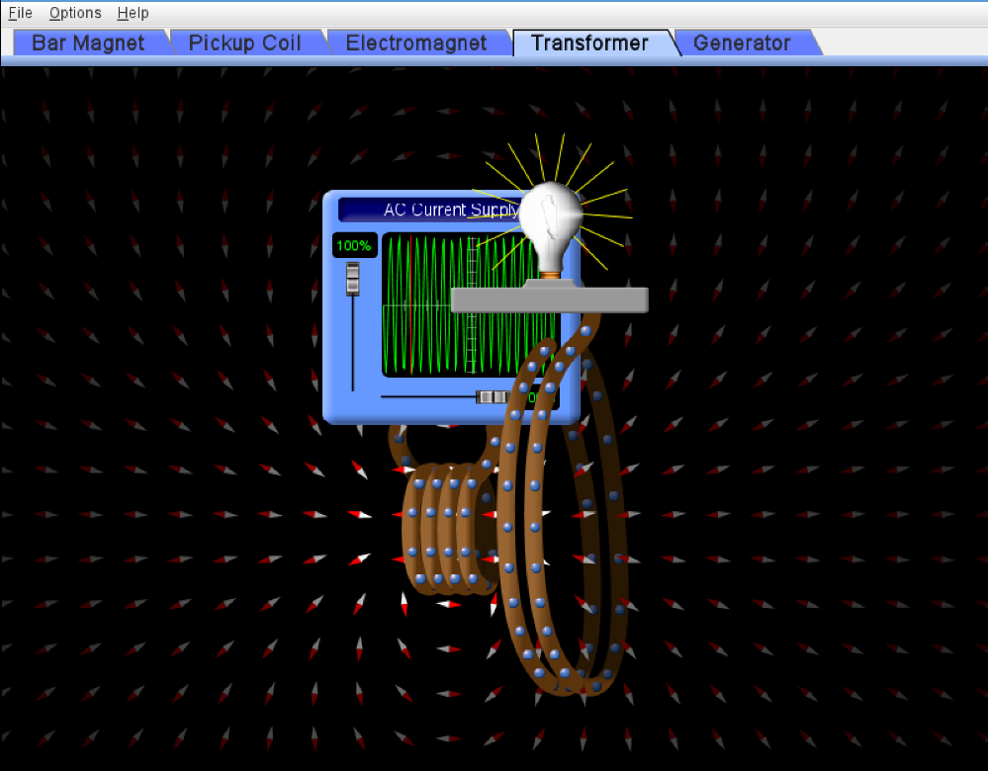

***Conclusion -:*** Observing the state of bulb at different stages, the condition required for induction to occur is concluded. The following points brief about the conditions required for induction:

* When the flux of magnetic field produced by an electromagnet at constant DC voltage is passed through the coil, the bulb doesn’t light up. It is observed in snap 1. Even though the flux through the coil is not zero, the bulb doesn’t light up. This means that passing of a magnetic flux through the coil is not the necessary condition for induction.
* When this electromagnet is moved towards the coil, the flux through the coil changed, and the bulb light up. It can be seen in snap 2. The bulb went off as soon as the electromagnet is held still. Moreover, when an AC supply is used in the electromagnet, the current and hence the magnetic field of electromagnet changed continuously, and the bulb light up. It can be seen in snap 3.
* **This means that the necessary condition for induction to occur is that there should be a varying magnetic field (or magnetic flux) through the coil**. If this is the case, then only a potential difference will develop in the coil and current will start to flow.

***Objective(vi)***

* ***Using light bulb to show the characteristics of induced current***

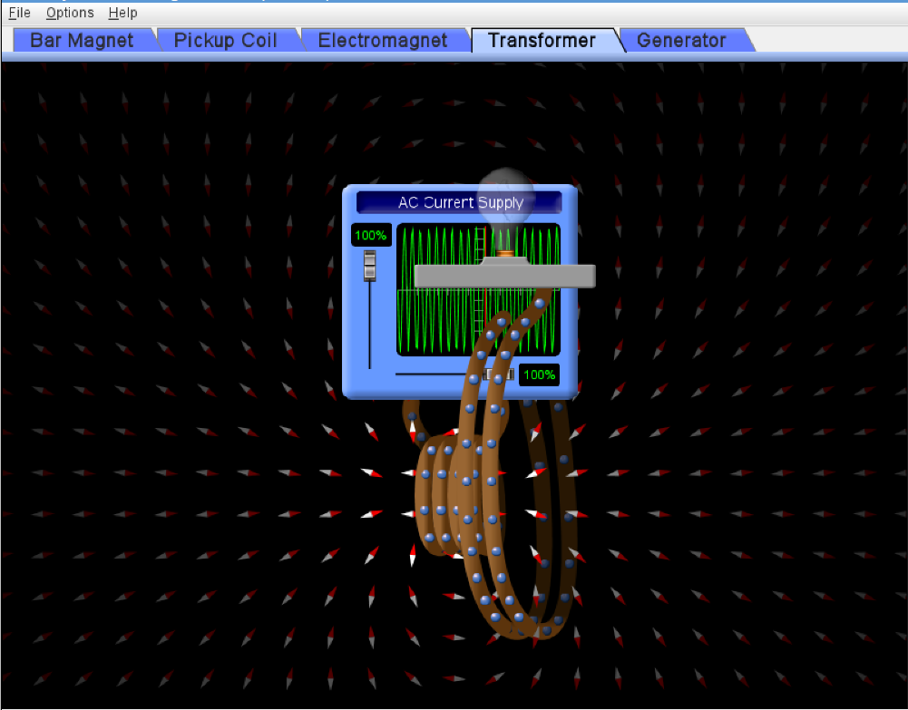

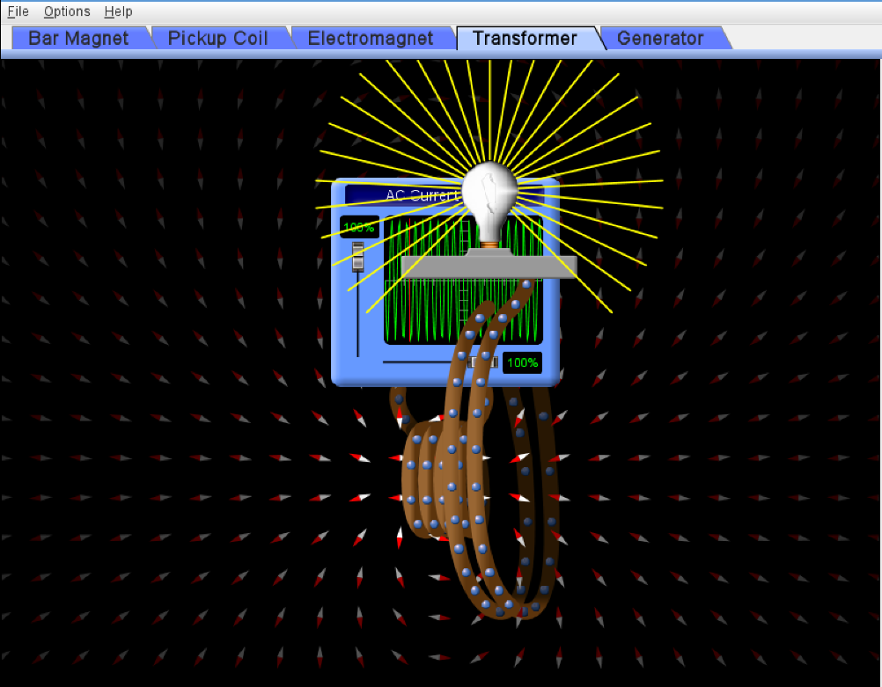

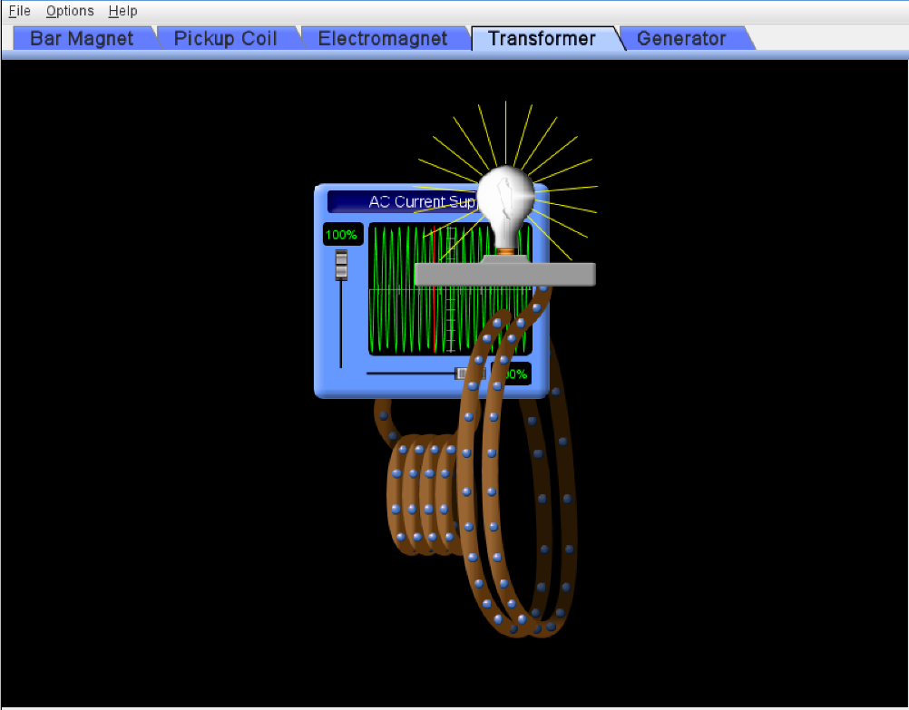

* ***Using voltmeter to show the characteristics of induced current***

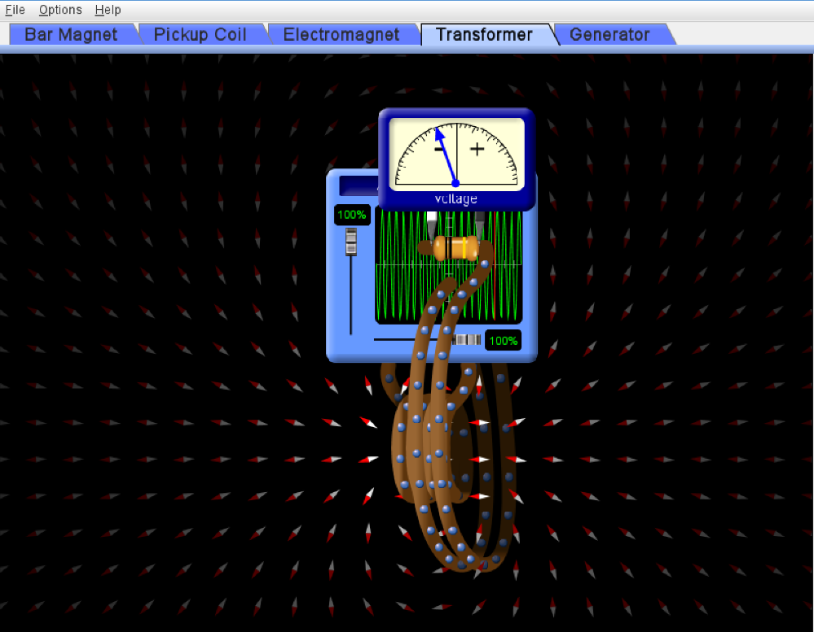

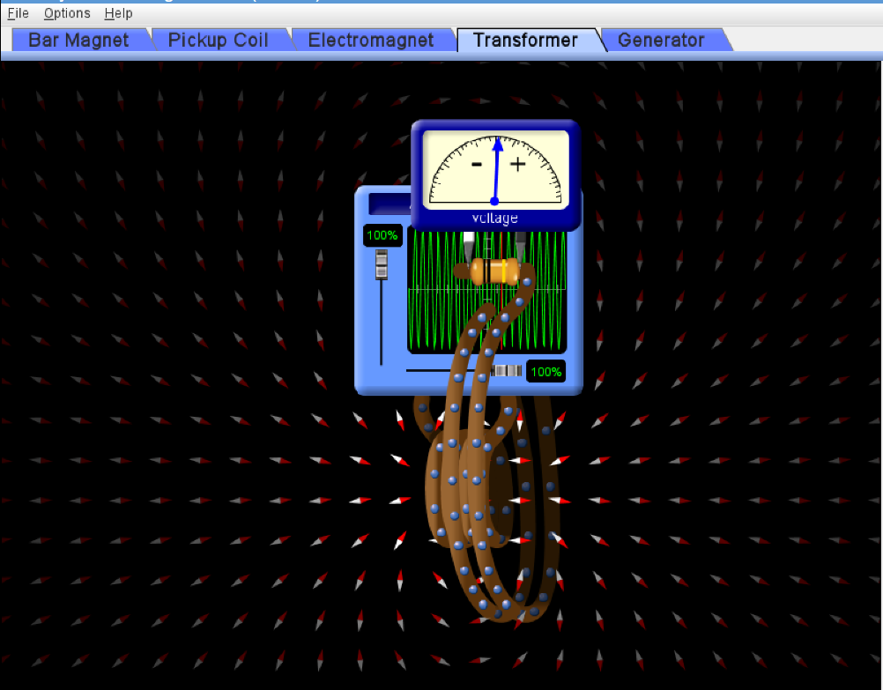

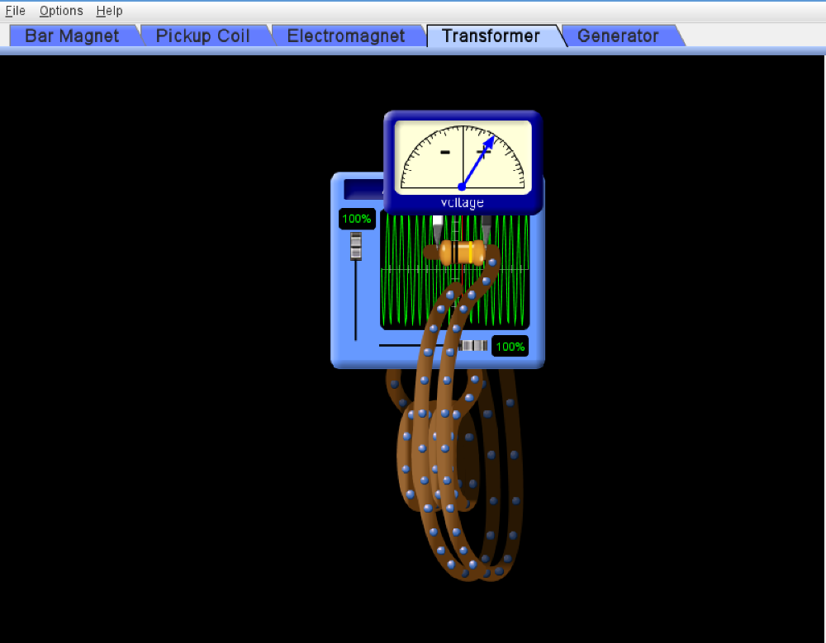

***Conclusion -:*** Observing the characteristics of induced current using light bulb and volt meter led us to the following conclusions -:

* Using light bulb gives us a qualitative idea about the rate of change of flux through the coil at any instant. According to Faraday’s Law, the emf induced in the coil is directly proportional to the rate of change of magnetic flux through it. When the rate of change of flux is large, the emf induced and hence the induced current is large, which leads to more brightness of the bulb. However, using light bulb doesn’t gives any idea about the exact magnitude of induced current at any instant.
* Using voltmeter provides the exact value of the emf induced in the coil at any instant as it measures the emf developed in the coil. When the rate of change of change of flux is large, the needle deflects more and shows a larger value. The induced current can then be calculated using Ohm’s law for the coil.
* Hence, both the voltmeter and light bulb can be used to show the characteristics of induced current. However, using light bulb gives only a qualitative idea while a voltmeter provides us the exact values.

***Objective(vii)***

* Keeping number of turns and the loop area constant and varying the rate of flow of water.

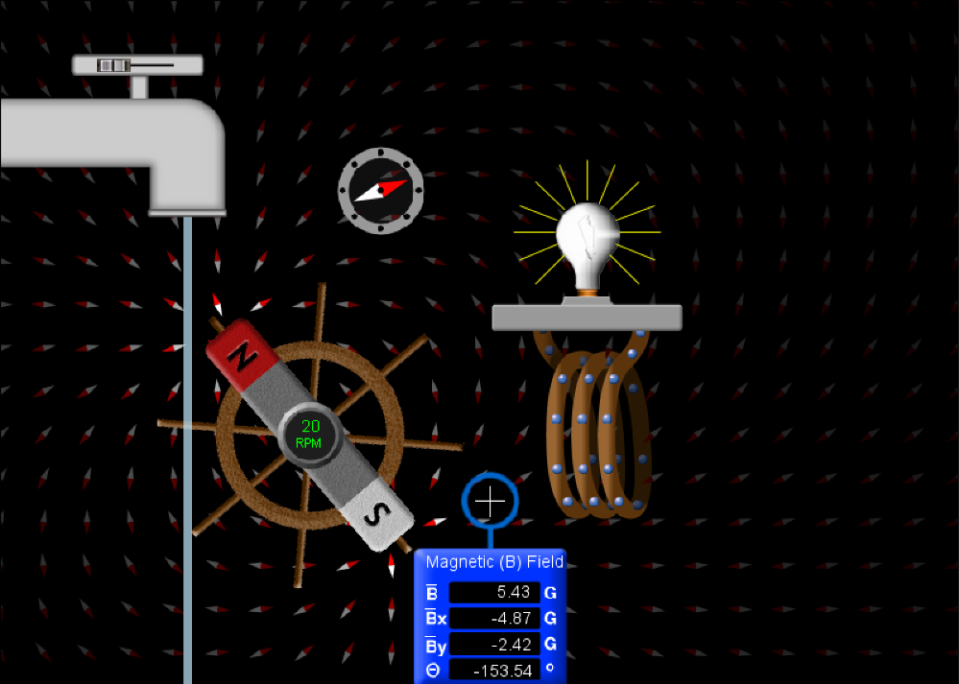

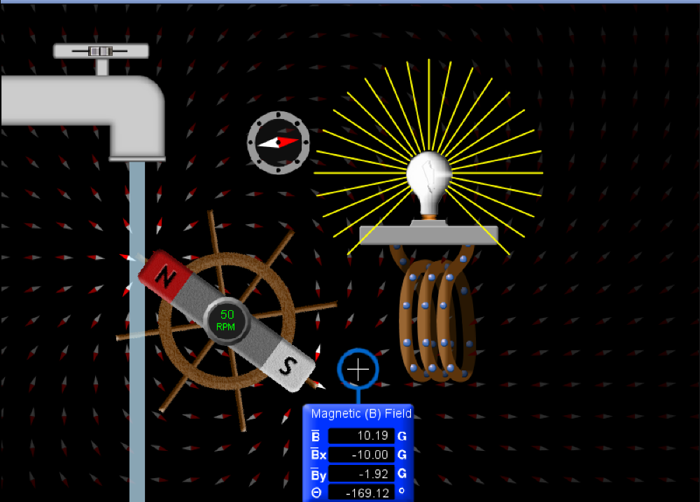

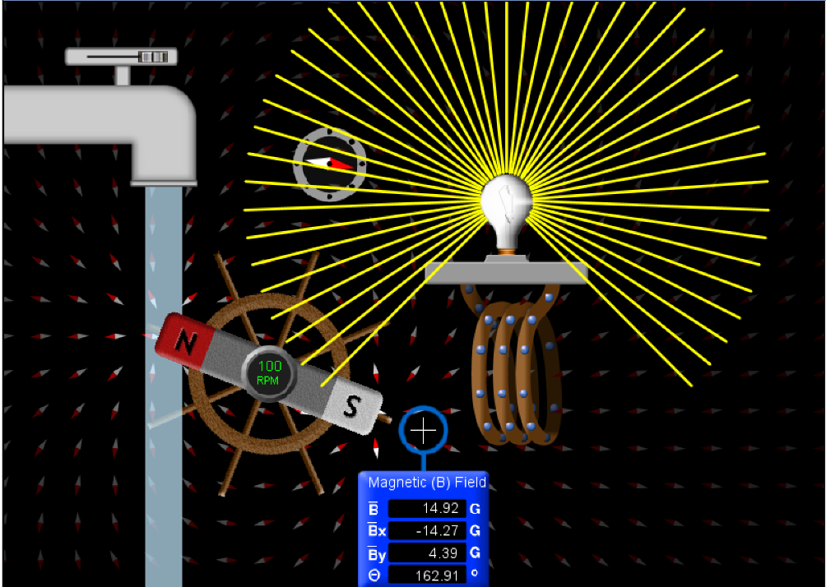

* Keeping number of turns and rate of flow of water constant and varying the loop area.

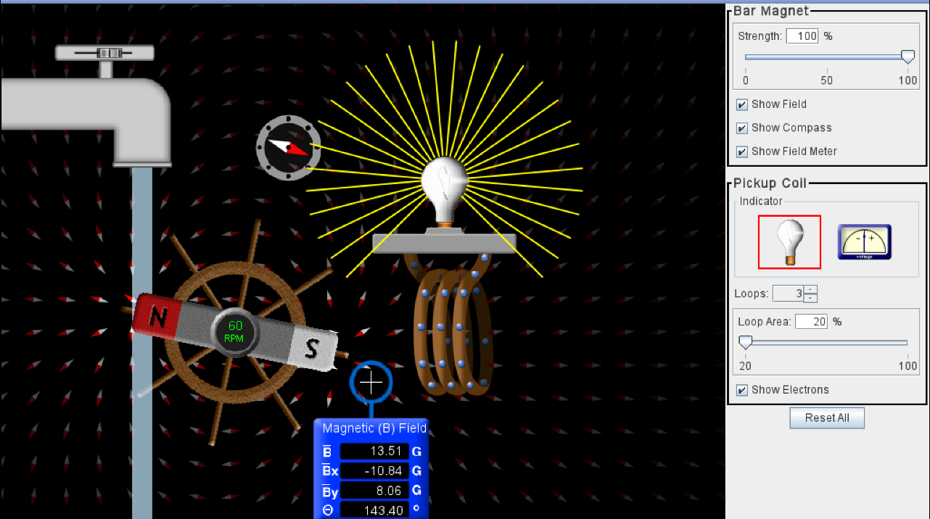

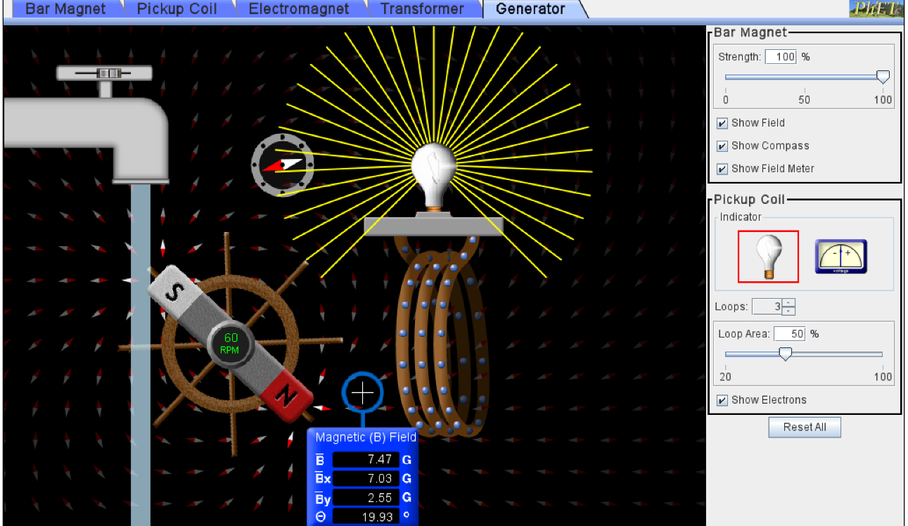

* Keeping loop area and rate of flow of water constant and varying the number of turns in coil.

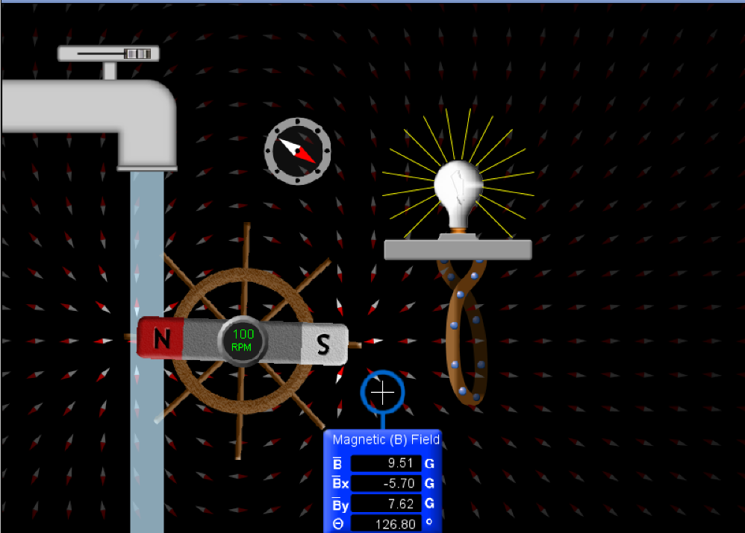 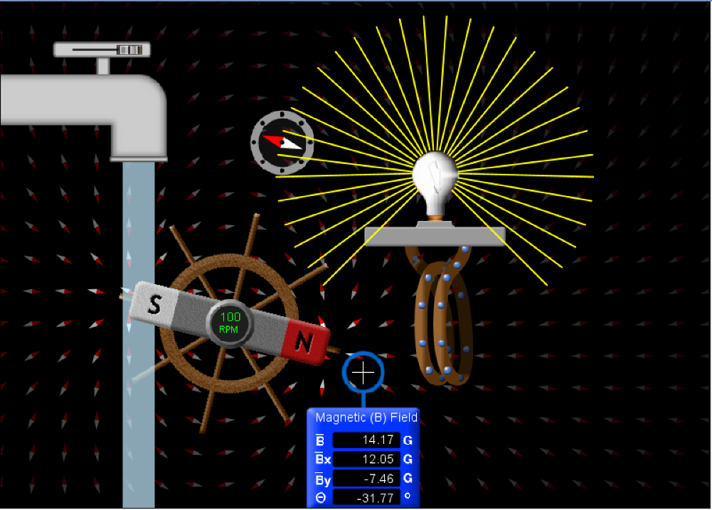

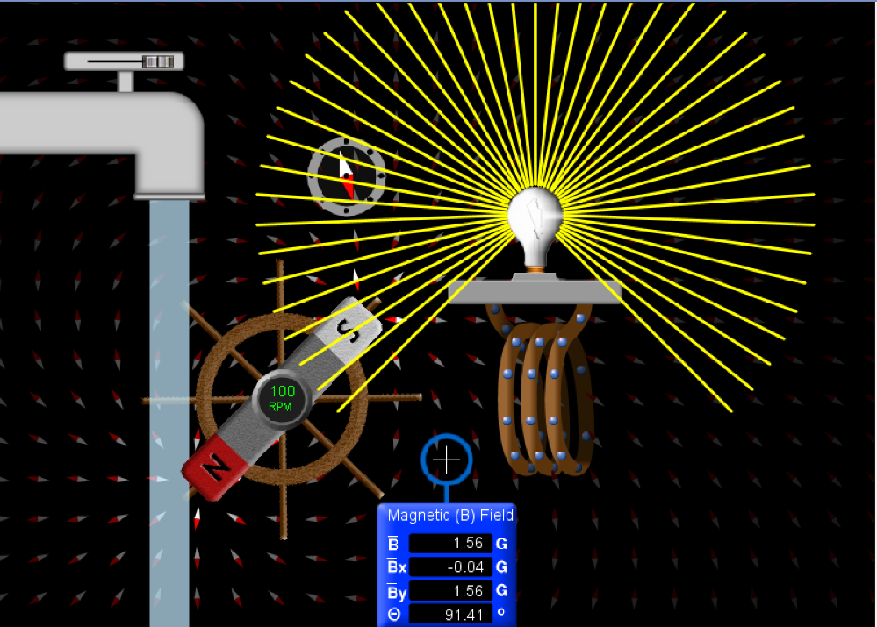

***Conclusion -:*** Observing the changes in the state of bulb and voltmeter, following conclusions can be drawn -:

* On varying the rate of flow of water while keeping other parameters constant, the brightness of the bulb was observed to be more on increasing the rate of flow. On doing so, the wheel rotates faster, which changes the flux through the coil rapidly i.e. the rate of change of magnetic flux increases through the coil. Hence, the emf developed and thus the current produced increases.
* On varying the loop area while keeping other parameters constant, the brightness of bulb doesn’t change. It remains the same for every loop area. This happens because although the total flux through the loop increases but the rate of change of flux doesn’t changes.
* On varying the number of turns in the coil while keeping other parameters constant, the brightness of bulb was observed to increase on increasing the number of turns. This happens because the flux now passes through each turn. Hence, the emf developed in the coil is directly proportional to the number of turns in the coil.
* On using a bar magnet of greater strength, the magnetic field strength produced by the magnet increases. This increases the rate of change of flux and the emf produced also increases.